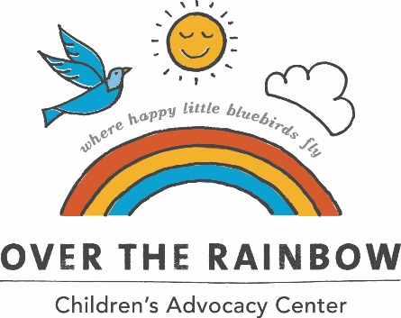

Name _______________________________ Organization/Company_____________________________

Mailing Address ______________________________ City_________________State ___ Zip _________

Email ______________________________________________Phone ____________________________

Item | Donation | Quantity | Total Amount
Pinwheel Flower Arrangement | $5.00
Additional Contribution

 |  | Total
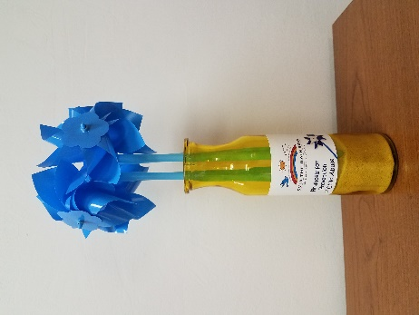

Contact Franklin County Children’s Advocacy Center to place an order at:
1461 S. Main St.
Chambersburg, PA 17201
Phone: 717-504-8491 FAX: 717-504-8659 email: dkelso@overtherainbowcac.org

